1. Initial Setup.

1. Adding components and adding their labels:

2911-Router - 2

3650-24PS-Switch – 1

2960-24TT – 8

PC - 8

Server - 3

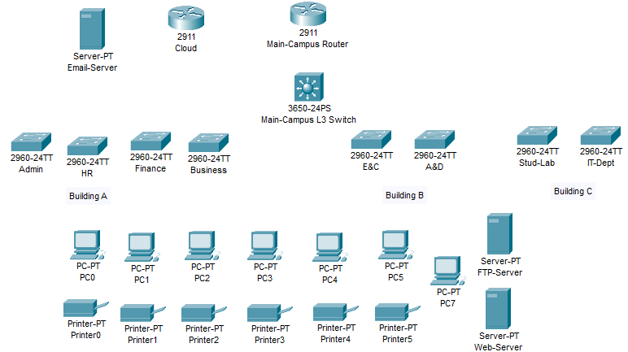

1. Serial Connection to Main Router and Cloud.

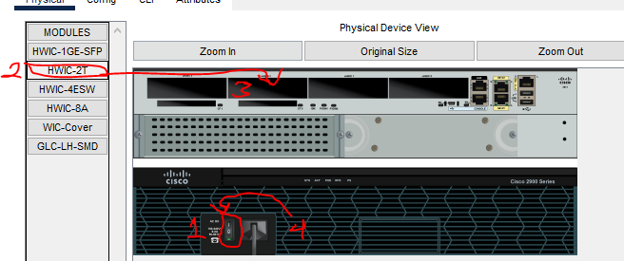

On Main Router, switch it off first, then move the HWIC-2T module to an empty slot then turn on again. Same process to 2911 Cloud Router.

1. Use automatic wires to connect other Devices.

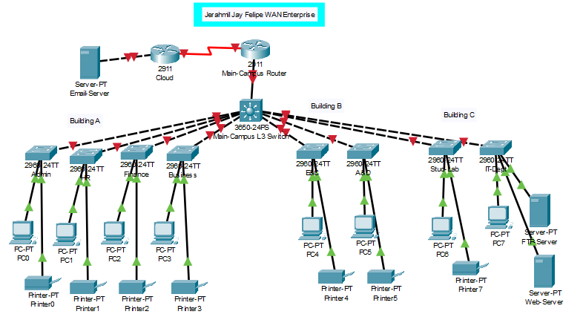

1. Design on preference.

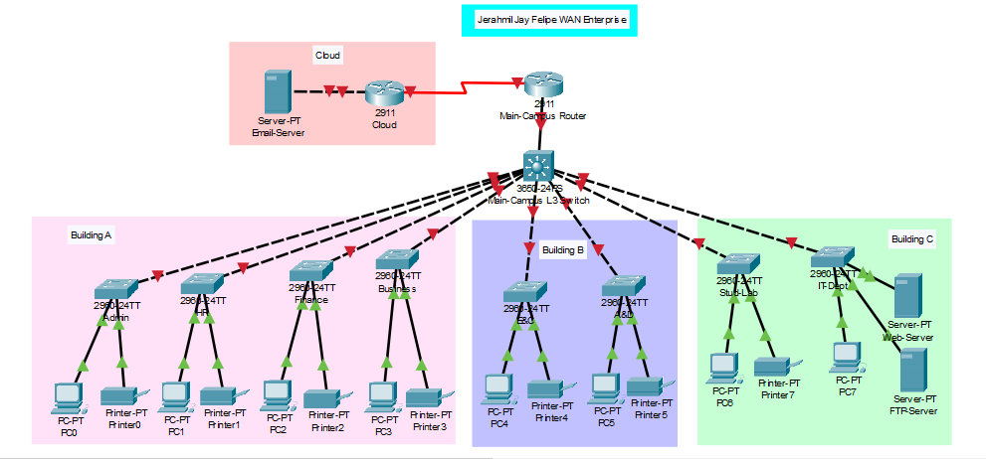

1. Add the Branch Devices.

1. Configure the 2911 Switch Branch here as Main-Campus Router to use series connection and connect it.

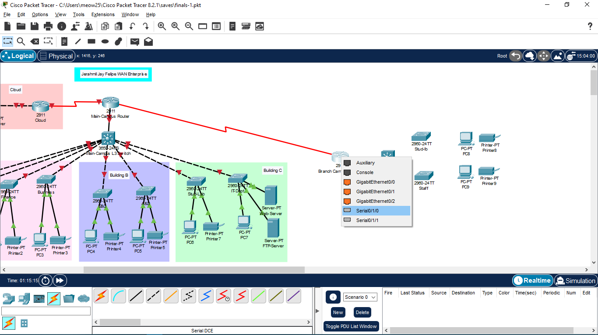

1. Design and Correct Labels for configuration.

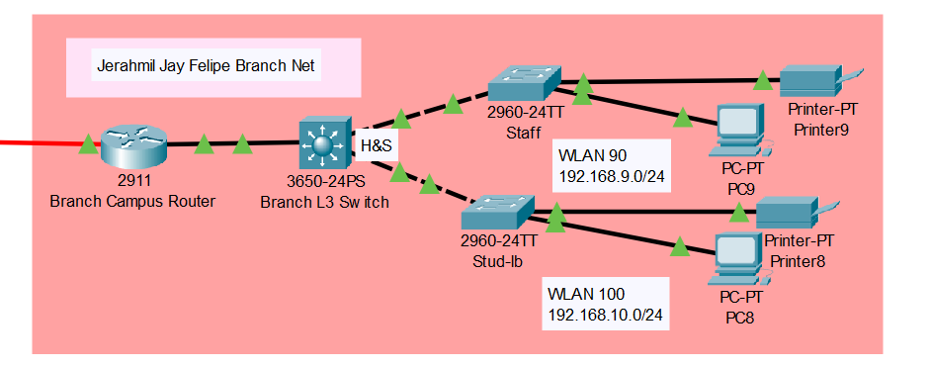

1. Configuration, set routers on.

1. Add Powersupply to 3650-24PS-Switches (both for Main and Branch).

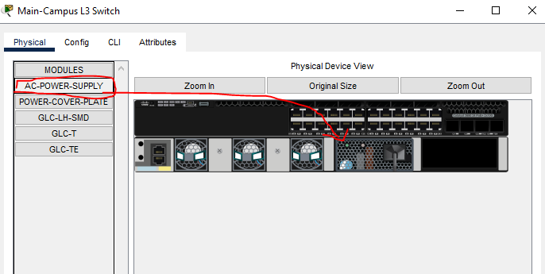

1. Configure the main router for its’ serial connection.

1. VLAN Configuration. (Admin, HR, Finance, Business, E&Q, A&D, Stud-Lab, IT-Dept) Switches.

Copy text from notepad and apply to all switches.

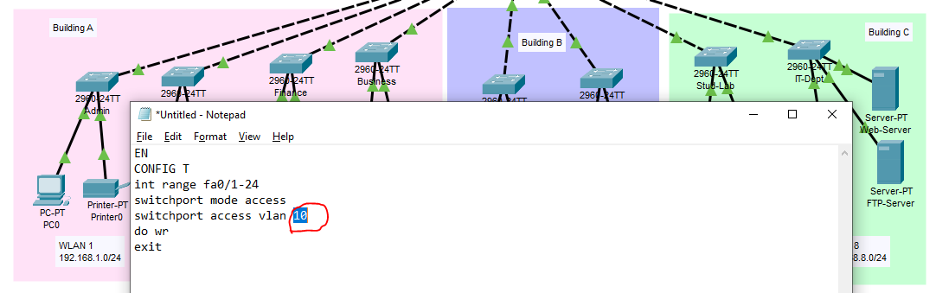

Note: Same configuration is used, it just varies on the WLAN IP Address. If on ADMIN then VLAN is 10, if on HR VLAN is 20, and so on.

1. Configure Main Switch.

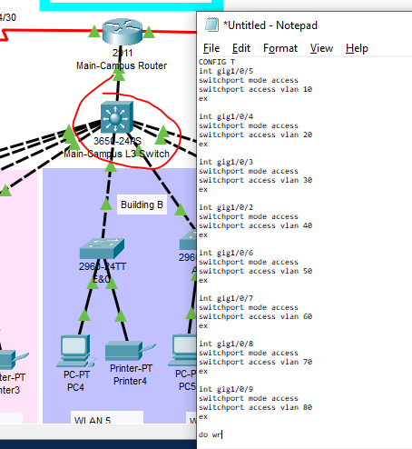

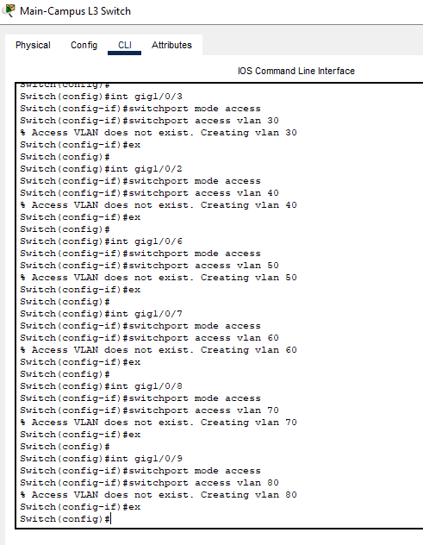

1. Config the Branch Net. Start with Switch.

1. Trunk Connection to the Layer Switches
2. A computer screen shot of a computer

   Description automatically generatedA screen shot of a computer

   Description automatically generated
3. Sub interface for IP.

Main Router:

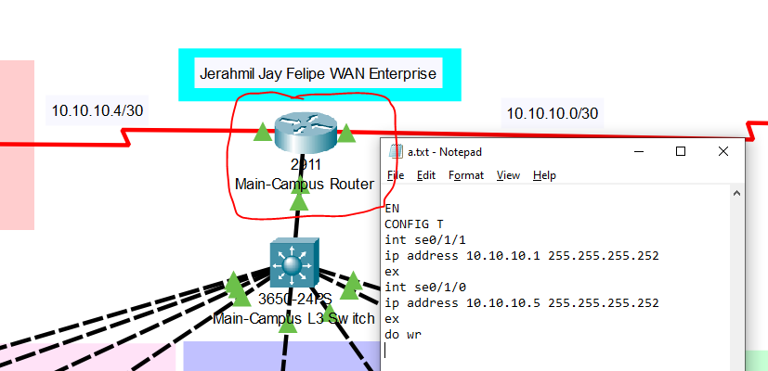

Branch Router:

Cloud Router:

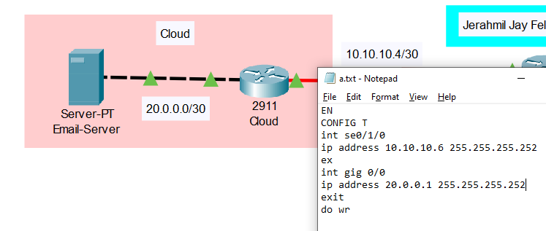

1. Apply IP to server Statically.

1. Inter-VLAN for Branch devices and use DHCP for dynamic IP Addressing.

1. Testing Ping: PC9 to PC8

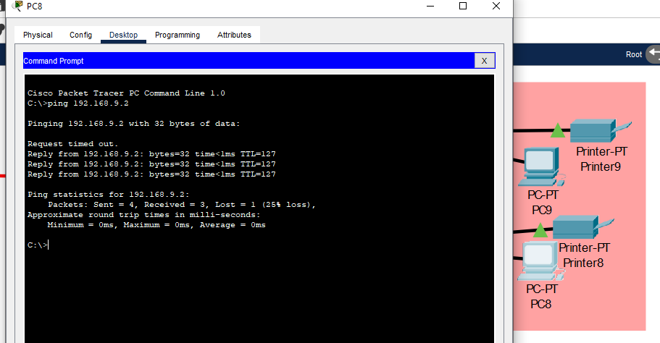

1. Do the same in Main Network: Creating sub interface in the router.

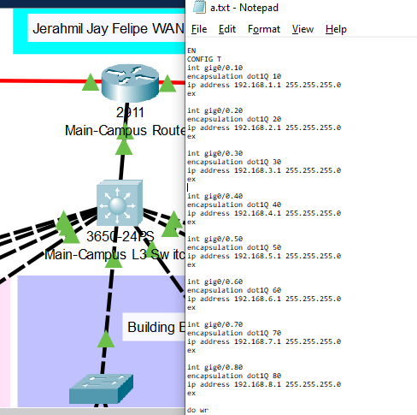

1. Configure all PC with DHCP.

1. Testing Ping.

PC0 to PC7:

PC4 to PC9:

Note: Communicating to other branch will lead to an unreachable connection.

1. Solving the communication problem of Main and Branch network.

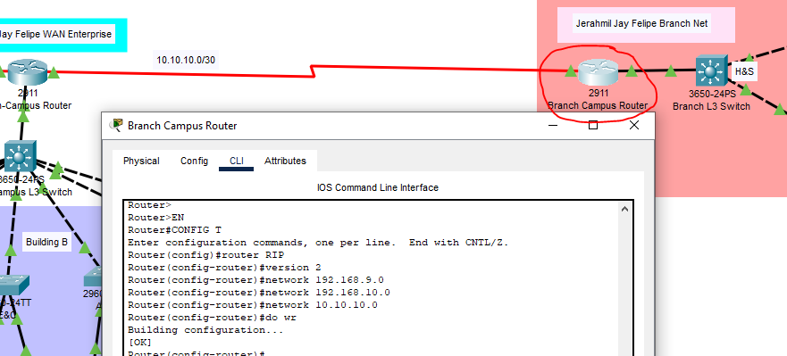

1. Testing Ping.

PC4 to PC9:

PC8 to PC0:

1. Configure Cloud.

1. Testing Ping to the Cloud. PC 8 to Server.

Overall Output

